Imagining the Promised Land

The Rev. Sarah K. Fisher
T
he Israelites knew what it meant to journey from scarcity to abundance. They did it time and time again. They fled by night, trusting God would guide them and provide for them. Who could have imagined that their journey to liberation would include the sea itself parting and their ability to walk through as though it were dry land? As they traveled through the wilderness, God joined them, feeding them manna, enough for the day, providing them fire by night, and cloud by day. It was not an easy journey, and at times, the Israelites stumbled and complained along the way. Still, God was with them, always, as they moved from a place of bondage to a place of freedom and abundant life.
For reflection…
• Where do you sense God inviting you to go and explore? Where do you need to be attentive to God’s invitation?
• What are you stewarding in your life? Where do you see God in your stewardship?
• How do you think the Israelites imagined the Promised Land as they were traveling? As you journey, how do you imagine the Promised Land?
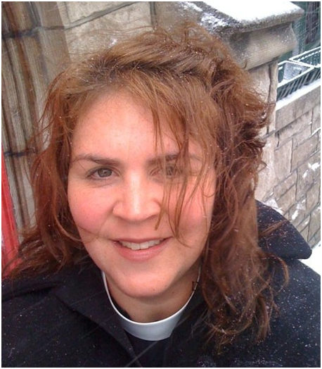
At its heart, stewardship is an invitation to journey into God’s abundance. And for most of us, the journey to generosity is just that — a journey. It is human nature to fear not having enough. Yet God’s story and our story collide and we experience something different. God invites us to taste and see what God is doing in our lives and to consider what God is entrusting to our care. In journeying to generosity, we are invited to become co-creators with God. When we move away from scarcity and self, we can begin to focus on what God has entrusted to us; we can see more fully how God is acting in our lives and in our world. In a culture that values our own enlightened self-interest over the needs of others, it is not always an easy journey, yet the gifts that await us when we truly step into community and into deep relationship with God are abundant.
The Rev. Sarah Fisher is Associate Rector of St. Patrick’s Episcopal Church in Atlanta, and the Vice-President of the Board of TENS. Early in her ordained ministry, she discovered a passion for stewardship after attending a TENS Conference. Ever since, she’s been talking, learning and being curious about the connections between money, church, spirituality and God. When she’s not in church, she can be found in coffee shops or thrift stores, or reading Harry Potter.

All of us are called to be stewards. We are stewards of God’s creation, stewards of our families, stewards of money, stewards of time, stewards of our churches, and stewards of the faith that has been handed down to us, the faith that so many generations before us have stewarded. As we travel with God, we begin to recognize those places in our lives where God is calling us, as God called the Israelites, to step forth in faith into new and unknown places. It can feel risky to let go of the familiar, the safe, the known. And yet, when we let go, when we invite God more fully into our lives, the journey cannot help but be one that transforms us, taking us out of our places of bondage, into new, generous and abundant life.

